Project 1

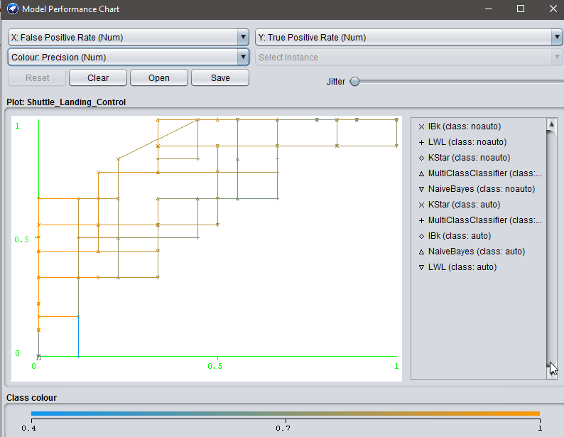

Fig: ROC curve

According to the ROC curve, NaiveBayes classifier was the best for the given dataset